Genesis Grant

CTEC 350 HW2

Wireshark

1. TCP, HTTP, DHCPv6, ARP, STP, SSDP, DNS, EIGRP, QUIC, CDP
2. It took .19 seconds for the HTTP get message to receive the HTTP OK reply.

1. The Internet address of gaia.cs.umass.edu is 128.119.245.12. The Internet address of my computer is 10.20.1.22
2. Printed Page

HTTP GET packet HTTP OK reply packet

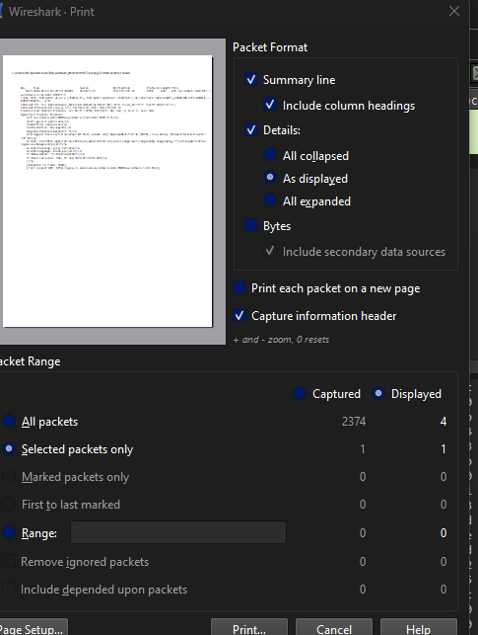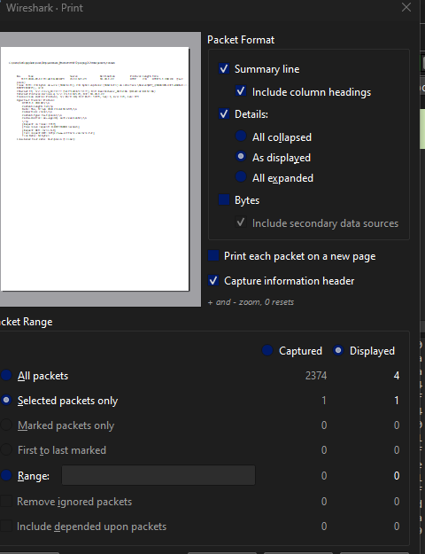

\*\*Screenshots below

1. Opening Browser

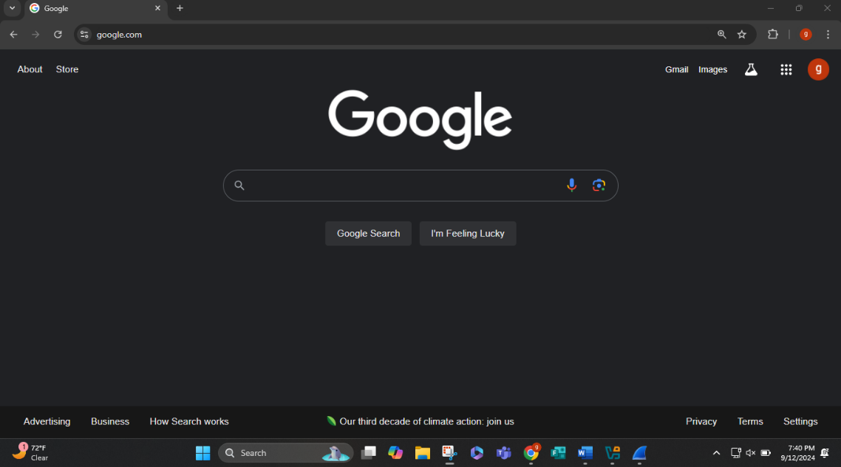

1. Opening Wireshark

1. Wireshark Capture pull down menu

4&5. Wireshark started

6.URL entered

7.\*Wireshark stopped

8.HTTP filtered

9. Packet-listing window